Breeding Schedule 2024
Bred to BG1 Medlar Meadow Romano (Polled):
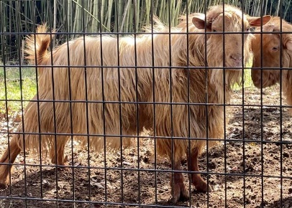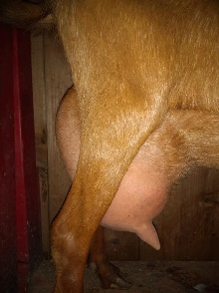(Full sister) 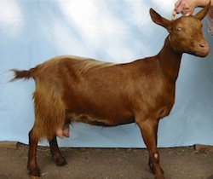(Dam)
WIF Ruthless (BG2) – Due March 10th – All on hold to retain
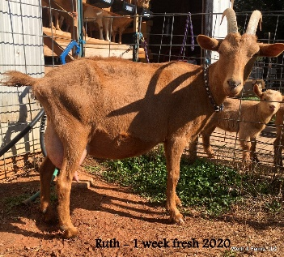

WIF Two Lea (BG2) – Due March 12th – Doelings (1st pick retained, 2nd available)
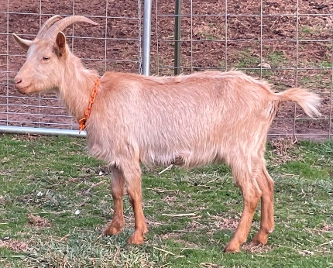(FF) (Dam’s udder)

WIF Davona Dale (BG1) –Due Feb 11^{th -} Doelings (1st pick retained, 2nd available)
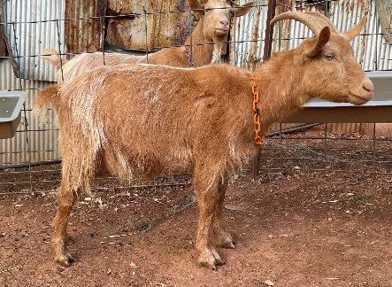(FF) (Dam’s Udder)

Piru Creek Diadem (HB2) – Due April 1st - AVAILABLE
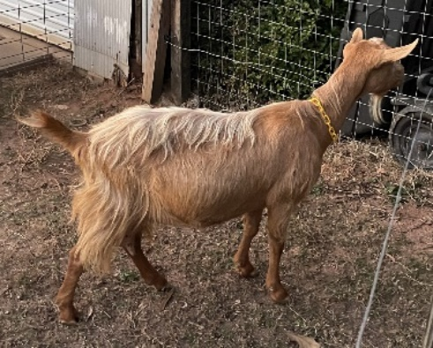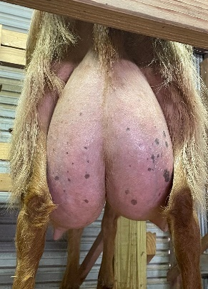

WIF Princess Rooney (BG2) – Due Feb 10th – ALL on hold to Retain
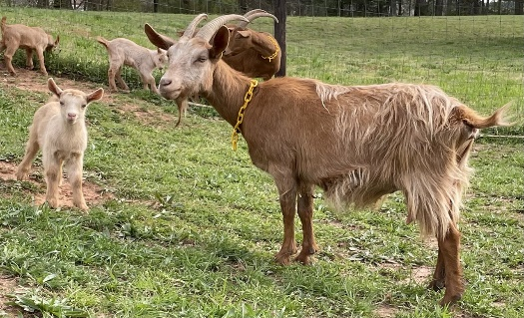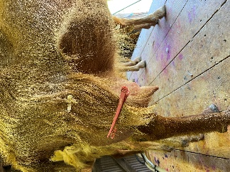

WIF Tosmah (HB3) – Due March 11th AVAILABLE
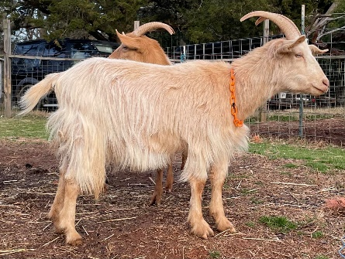(FF) 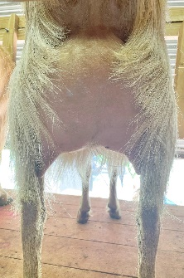 (Dams Udder)
WIF So Blessed (HB3) – Due Feb 11th AVAILABLE
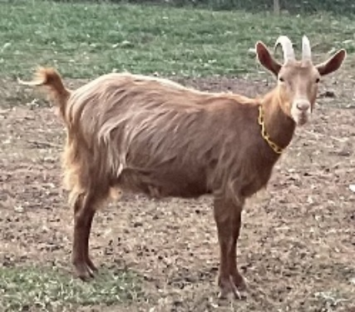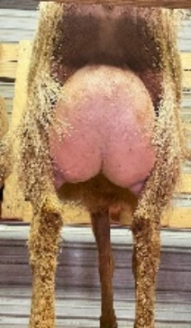
WIF Miss Woodford (HB3) (polled) – Due Feb 11th AVAILABLE
*Expecting bottle bucklings which will be available immediately*
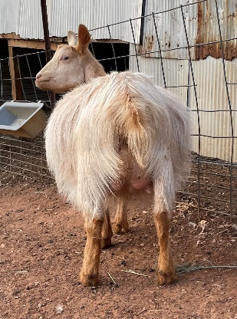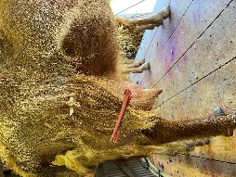

Bred to BG2 Piru Creek Boudin (horned):
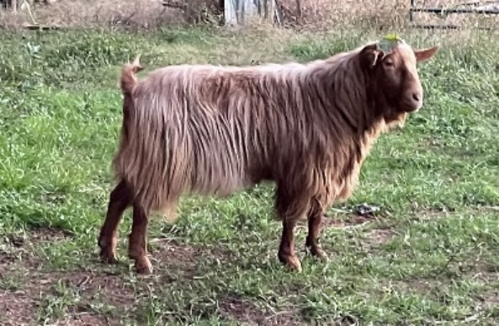
Dam’s Milk Test: Piru Creek Tiramisu
2 yr old – 353 days, 2656# total, 112# butterfat, 87# protein. Up to 10.6# in a day.
WIF Petrushka (HB+) – Due April 6th AVAILABLE
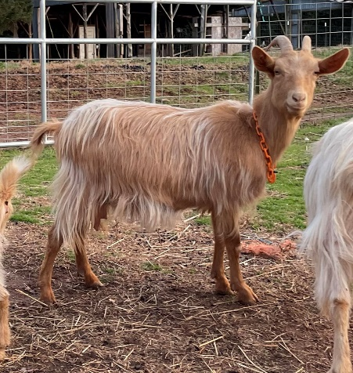(2nd Freshener) 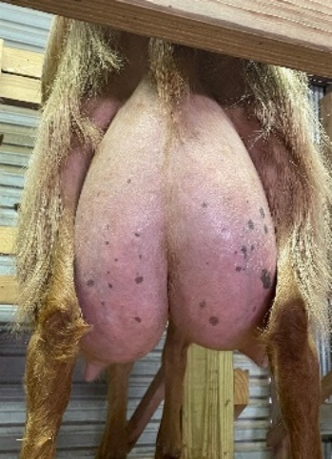 (Dam’s udder)

WIF Landaluce (HB+) – Due March 22nd AVAILABLE
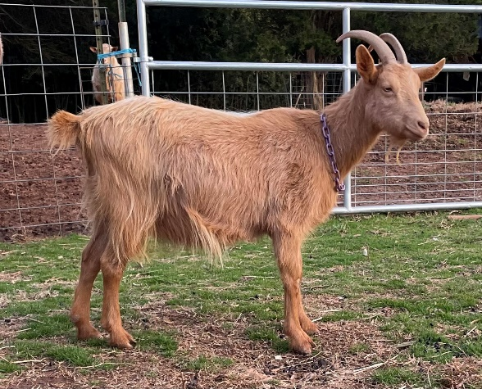 (2nd freshener) 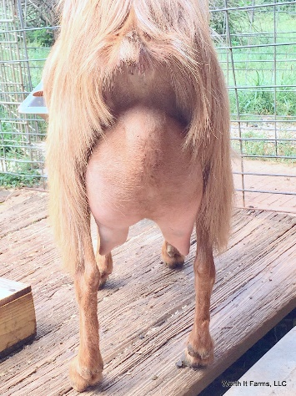 (Dam’s udder)
WIF Fashion (HB2) – Due March 22nd AVAILABLE
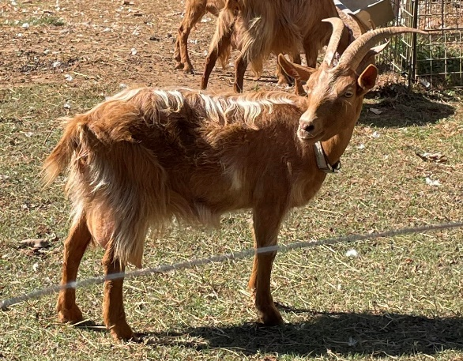
WIF Cicada (HB+) – Due March 9th Bucklings available, doelings retained
