HB WIF Wintergreen $600
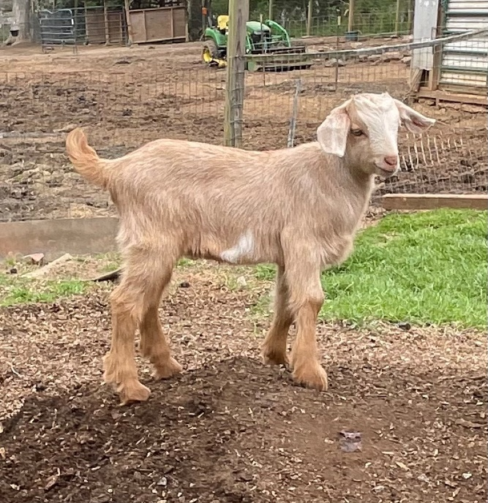
A father-daughter breeding that we are excited to see how it turns out. This buckling is horned and should have lovely conformation. His maternal half sister, Tosmah, is with us and has a beautifully attached udder along with her dam, so he should be able to put out daughter who are milk champions! DOB: 3/8/24
Sire: Piru Creek Boudin BG000828D Dam: WIF Cicada HB079772H
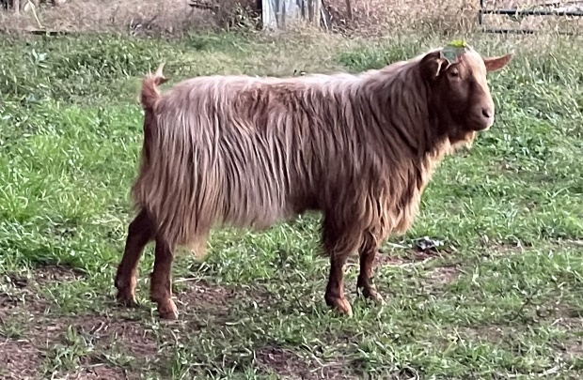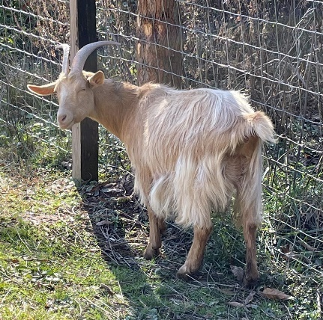
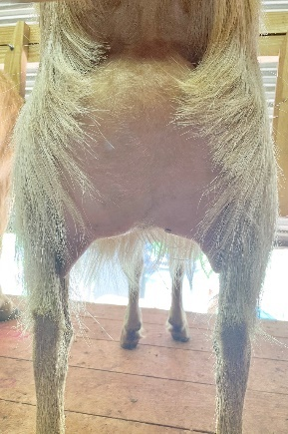 FF Udder

HB WIF Didia $600
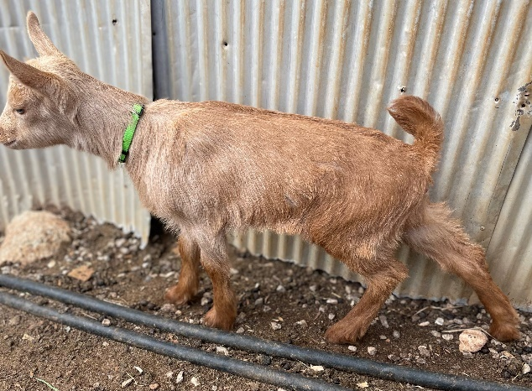
This is a polled doeling who is 25% GG. We are keeping her twin who is horned. We expect loads of milk and a shaggy darker coat out of this pairing. DOB: 3/10/24
Sire: Medlar Meadow Romano BG000927P Dam: WIF Tosmah HB080823H
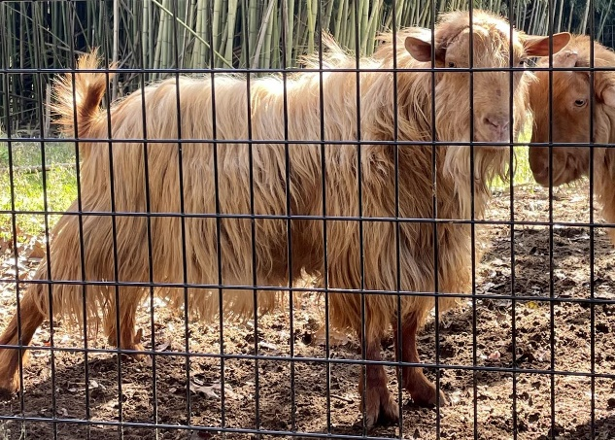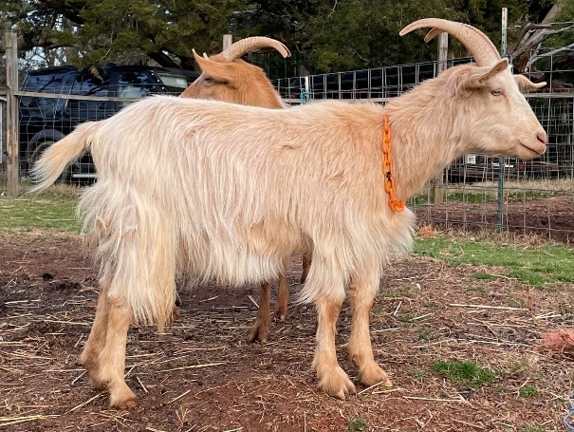

BG WIF Sir Huon $600
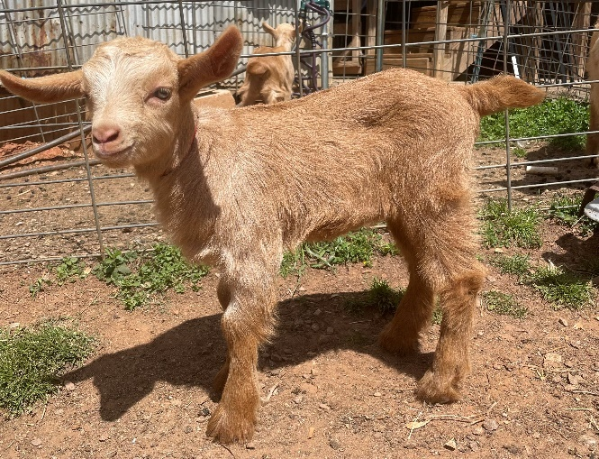
I was hoping for a doeling out of this pairing as the milk quantity would’ve been enough to rival a small cow! But a large buckling is what we got. This boy is horned and a lovely mid gold. Mid length coat and solid, wide conformation is expected.
He is available alone or with his dam ($1400) – who is skittish but milks like CRAZY.
Sire: Piru Creek Boudin BG000828D Dam: WIF Fashion HB080532H
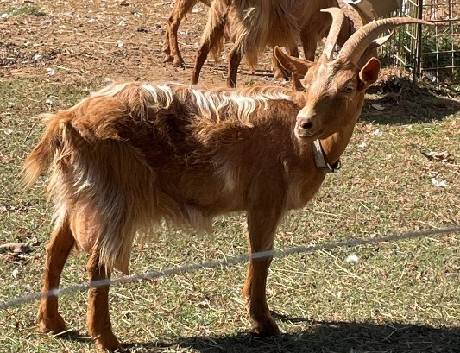

HB WIF Pink Star $550
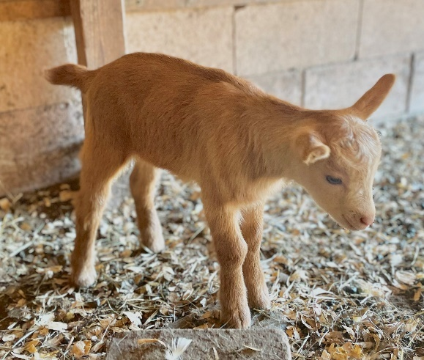
This bloodline refused to cooperate this year,lol. We were hoping for a polled buckling out of this pairing – but we got a horned one! But, wow is he a big sturdy boy (already the same size as his 3 week old half sisters)!! Diadem milks like a cow – seriously nearly 2 gallons of colostrum. But attachment will need work, excellent choice for a breed up to does with good solid attachment. His dam is a BIG, BIG girl so we expect he will grow larger than most Guernsey bucks (more reasons to cross with full size standard breeds).
Can go alone or with dam in milk ($1500).
Sire: Medlar Meadow Romano BG000927P Dam: Piru Creek Diadem HB079303D
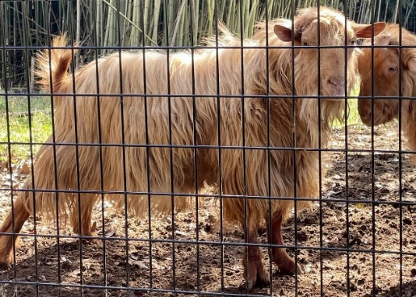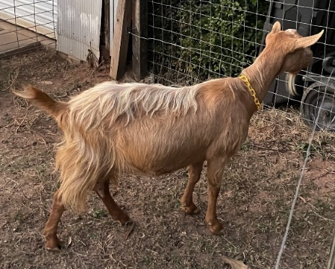
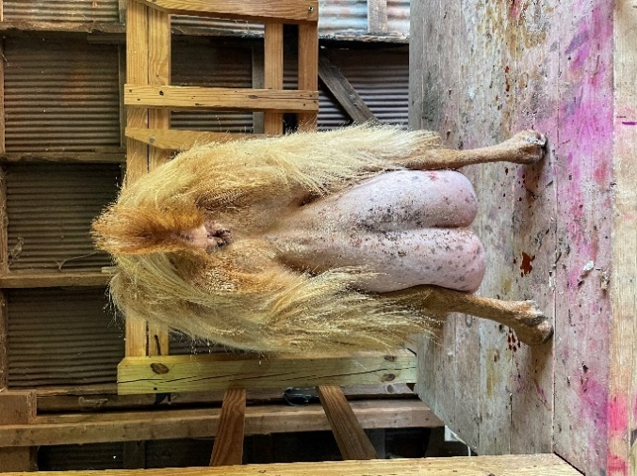
Diadem Pre-freshening 2024 (nearly 2 gal of colostrum!)

HB WIF Bewitch / Half Sister $600
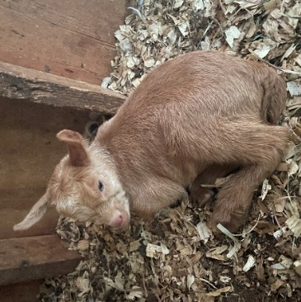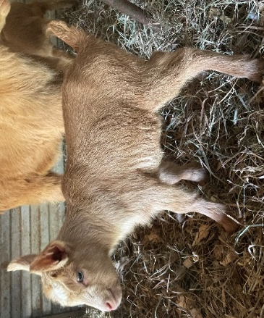2024 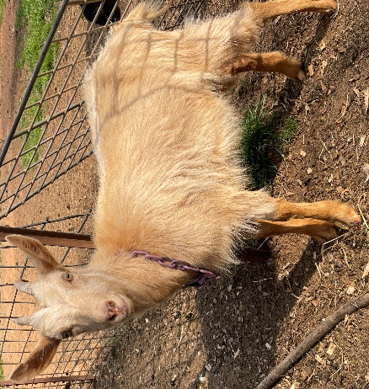2023
Same line as Diadem and Fashion. Petrushka gave us two doelings this year and a surprise set of twins last year. So, we can’t keep everyone (much to my dismay) and need to offer one of the 3 doelings for sale. They are all horned, one by WIF Montrose and two by Piru Creek Boudin. We are debating which will sell and which will stay but someone will go.
2023 Sire: WIF Montrose HB080310P Dam: WIF Petrushka HB080476H
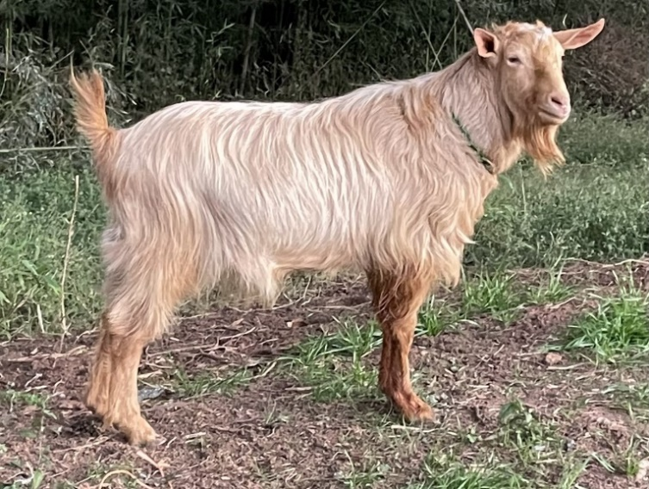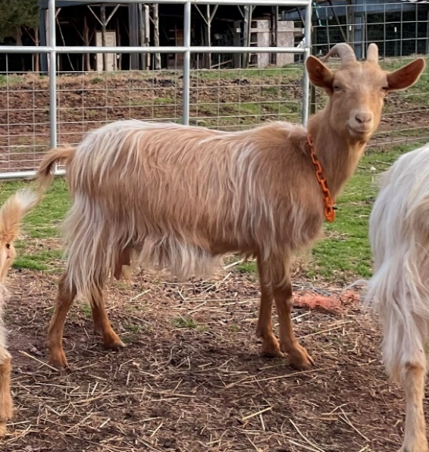

HB080477P WIF Miss Woodford & buckling $1050
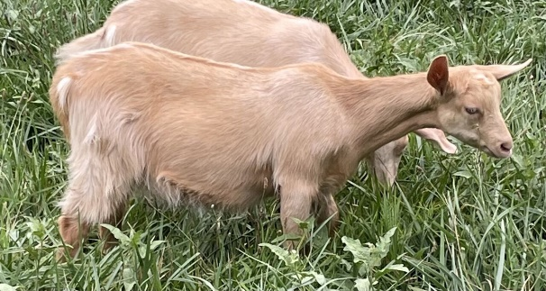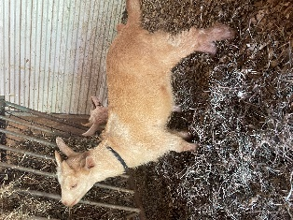
This polled two year old FF is being sold in milk. We are not milk sharing with her, just allowing her buck to nurse freely. She is an excellent mother and could be used as a nurse doe. She came into milk precociously last year just to nurse two of the babies she was close to and dotes on her son. We would prefer they go together and have priced him as an unregistered wether. She has had a rough life and is super tough to have survived it all. She broke her leg last year jumping a gate and healed up wonderfully! This years’ birth was traumatic (not something that will continue to be a problem, just bad luck) but she bounced right back and keep going. She is a sweet thing and we’d love to see her in a small group where she will get a lot of attention.
Sire: WIF Leonatus HB080354P Dam: WIF Princess Rooney BG001302H
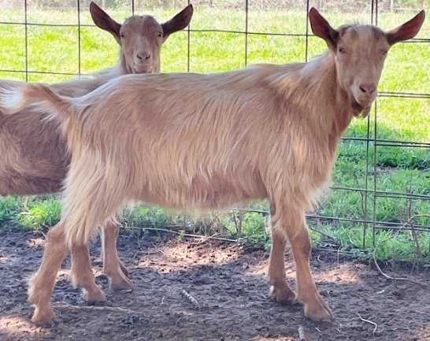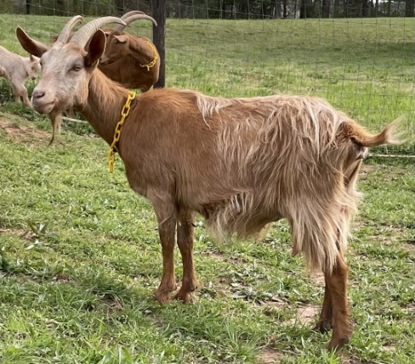
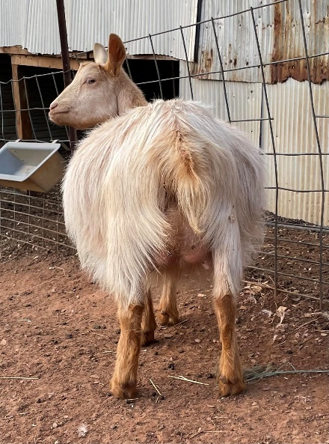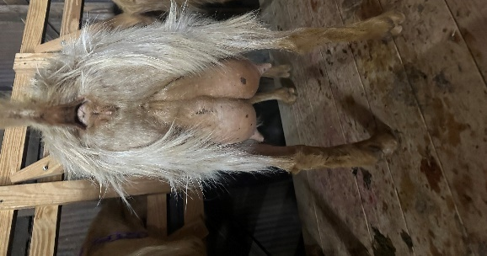
Pre-fresh Udder / 6 hr fill 6 weeks fresh

